**DAILY ONLINE ACTIVITIES SUMMARY**

|  |  |  |  |  |  |  |  |  |
| --- | --- | --- | --- | --- | --- | --- | --- | --- |
| **Date:** | **11-06-2020** | | | | | **Name:** | **Anix Jugal D’Cunha** | |
| **Sem & Sec** | **8 sem , A sec** | | | | | **USN:** | **4AL16CS013** | |
| **Online Test Summary** | | | | | | | | |
| **Subject** | | **SMS** | | | | | | |
| **Max. Marks** | | **60** | | **Score** | | | **60** | |
| **Certification Course Summary** | | | | | | | | |
| **Course** | **The Hands On Machine Learning Course** | | | | | | | |
| **Certificate Provider** | | | **Udemy** | | **Duration** | | | 37 mins |
| **Coding Challenges** | | | | | | | | |
| **Problem Statement:** recursive function to calculate the sum of numbers from 0 to 10 | | | | | | | | |
| **Status: Competed** | | | | | | | | |
| **Uploaded the report in Github** | | | | | **yes** | | | |
| **If yes Repository name** | | | | | **alvas-education-foundation/dcunhaanixjugal** | | | |
| **Uploaded the report in slack** | | | | | **yes** | | | |

Online Test Details: (Attach the snapshot and briefly write the report for the same)

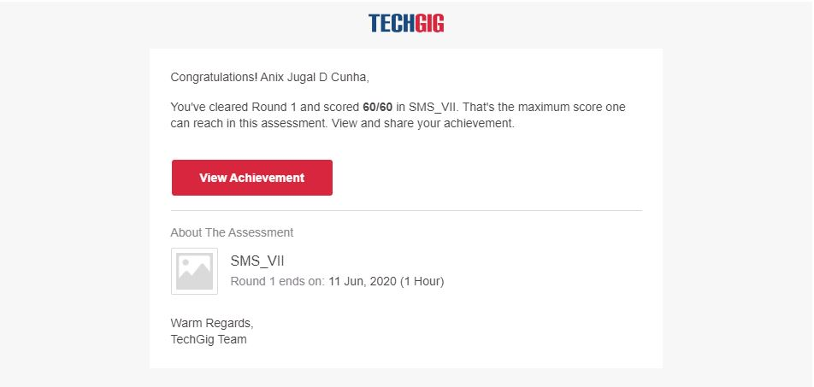

Certification Course Details: (Attach the snapshot and briefly write the report for the same)

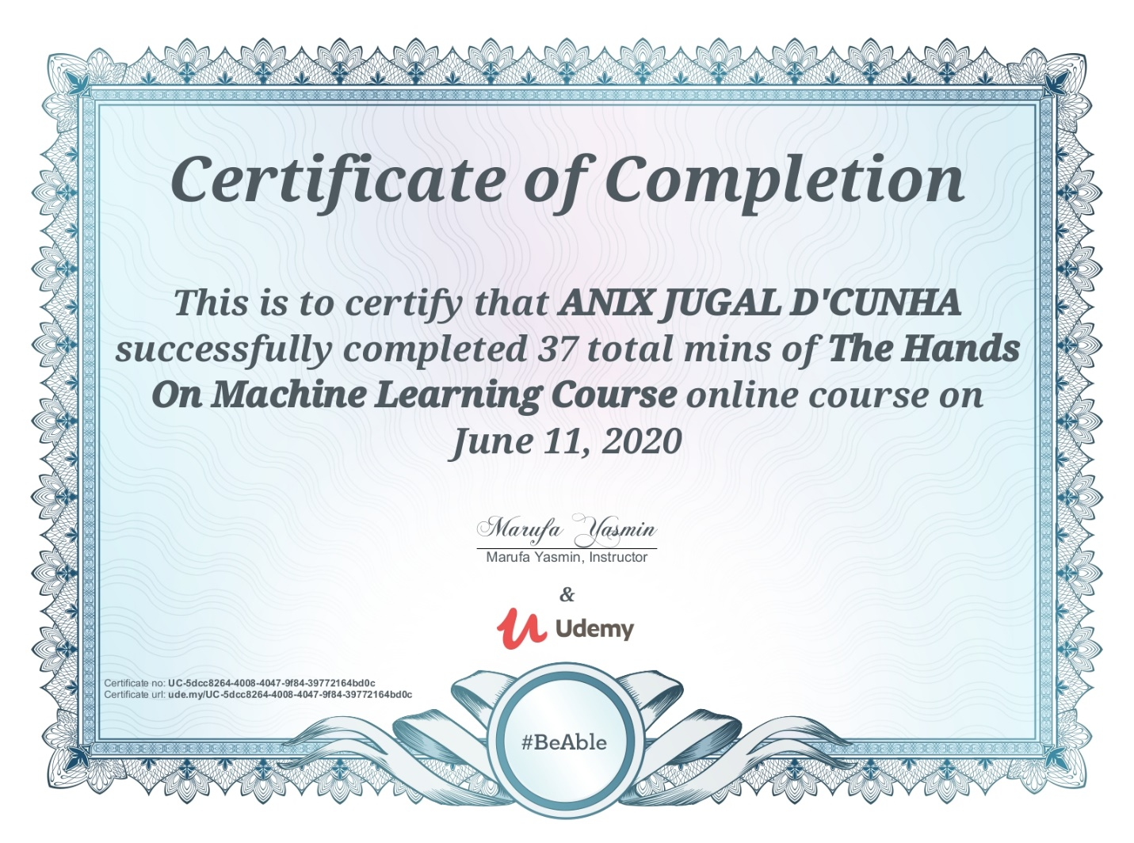

Coding Challenges Details: (Attach the snapshot and briefly write the report for the same)

Program-> #recursive function to calculate the sum of numbers from 0 to 10

def calculateSum(num):

if num:

return num + calculateSum(num-1)

else:

return 0 res = calculateSum(10)

print(res)